1.Food Order Page

In this [assignment](http://192.168.253.177/moodle/mod/assign/view.php?id=9464), let's build a Food Order Page by applying the Bootstrap concepts we learned till now.

**Refer to the below image.**

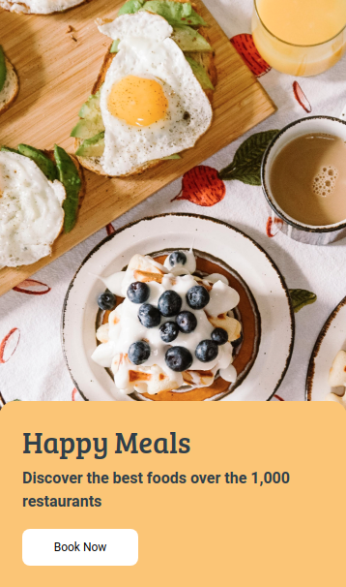

**Note**:

Try to achieve the design as close as possible.

**Resources**

Use this background image,

URL: <https://d1tgh8fmlzexmh.cloudfront.net/ccbp-static-website/foodbg.png>

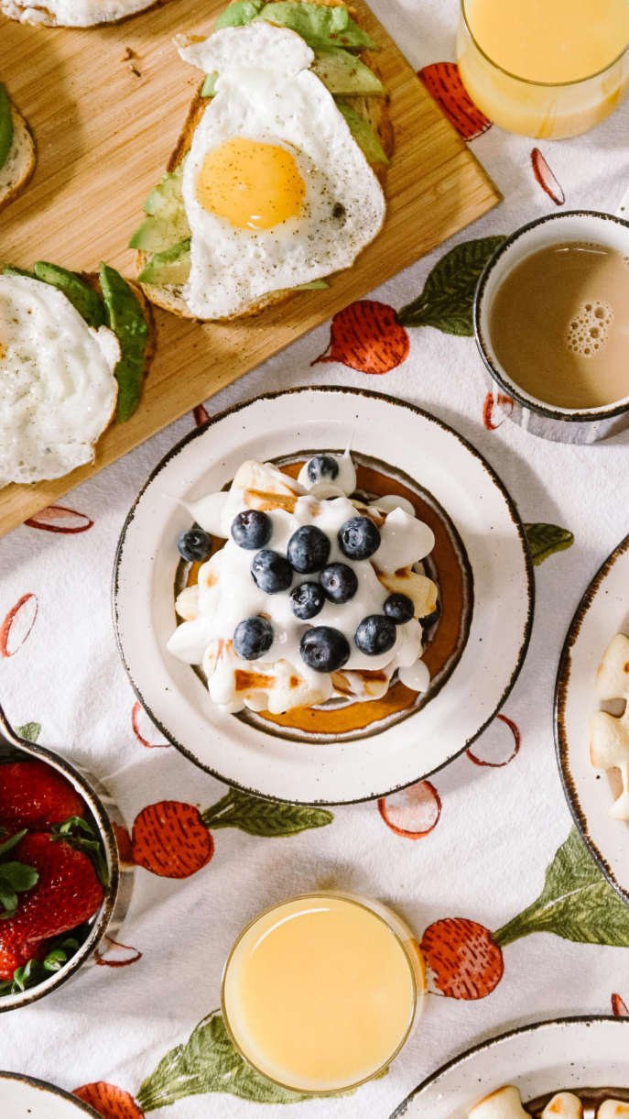

**CSS Colors used:**

Background color Hex Code value for card:

* #f6c56e

Background color Hex Code value for Button:

* #ffffff

Text color Hex code value:

* #323f4b

**CSS Font families used:**

Main Heading

* Bree Serif

Paragraph and Button

* Roboto

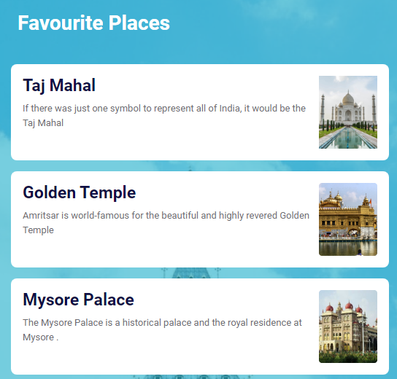

4.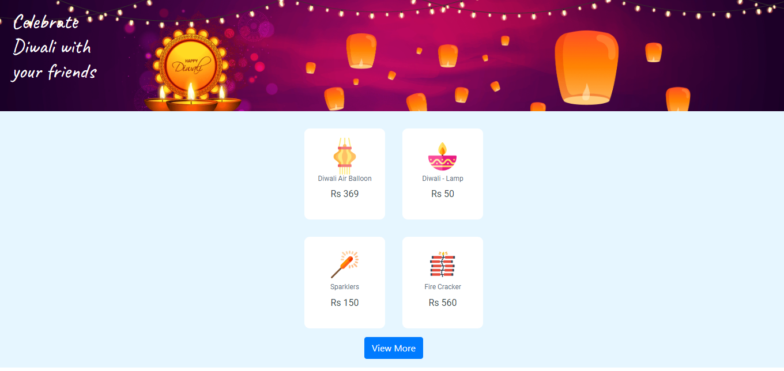

**Resources used to develop a Diwali Page**

**URL of background image**:

* https://d1tgh8fmlzexmh.cloudfront.net/ccbp-static-website/diwali-bg.png

**URLs of card item images**:

* https://d1tgh8fmlzexmh.cloudfront.net/ccbp-static-website/lamp-img.png
* https://d1tgh8fmlzexmh.cloudfront.net/ccbp-static-website/diya-img.png
* https://d1tgh8fmlzexmh.cloudfront.net/ccbp-static-website/firework-img.png
* https://d1tgh8fmlzexmh.cloudfront.net/ccbp-static-website/firecracker-img.png

**Colors and Background colors**:

* white

Hex code color values:

* #e6f6ff
* #616e7c
* #323f4b

**5.Advanced Technologies Cover Page**



**Resources**

Use this background image,

URL: <https://d1tgh8fmlzexmh.cloudfront.net/ccbp-static-website/arvrbg.png>

**CSS Colors used:**

Background color Hex Code value for card:

* #ffffff

Background color Hex Code values for buttons:

* #5752ab
* #ffffff

Border color Hex Code value for button:

* #d7dfe9

Text color Hex Code values:

For main heading:

* #5752ab

For paragraph:

* #323f4b

For buttons:

* #171f46
* #ffffff

**CSS Font families used:**

* Bree Serif
* Roboto



**Resources**

Use this background image,

URL: <https://d1tgh8fmlzexmh.cloudfront.net/ccbp-static-website/newsbg.png>



**CSS Colors used:**

Background color Hex Code value for card:

* #ffffff

Background color Hex Code value for button:

* #323f4b

Text color Hex Code values:

For main heading:

* #323f4b

For paragraphs:

* #7b8794

For button:

* #ffffff

**CSS Font families used:**

* Roboto

7.Cricketer Page

In this [assignment](http://192.168.253.177/moodle/mod/assign/view.php?id=9464), let's build a Cricketer Page by applying the concepts we learned till now. You can use the Bootstrap concepts as well.

**Refer to the below image.**

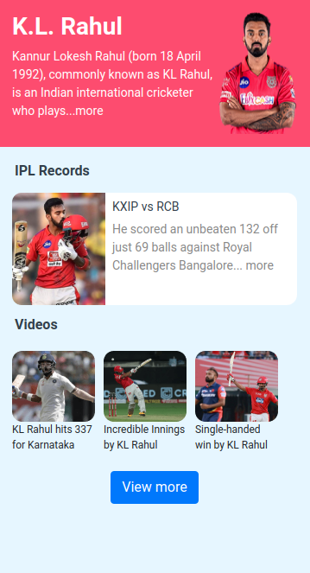

**Note**:

* Try to achieve the design as close as possible.
* This is a sample Cricketer Page. You can build your favourite Cricketer's Page using this as a reference.

**Resources**

Use the image URLs given below.

* <https://d1tgh8fmlzexmh.cloudfront.net/ccbp-static-website/klrahul-img1.png>
* <https://d1tgh8fmlzexmh.cloudfront.net/ccbp-static-website/klrahul-img2.png>
* <https://d1tgh8fmlzexmh.cloudfront.net/ccbp-static-website/klrahul-img3.png>
* <https://d1tgh8fmlzexmh.cloudfront.net/ccbp-static-website/klrahul-img4.png>
* <https://d1tgh8fmlzexmh.cloudfront.net/ccbp-static-website/klrahul-img5.png>

**CSS Colors used:**

Background color Hex Code value for Top Section:

* #fb4e71

Background color Hex Code value for Bottom Section:

* #e6f6ff

Background color Hex Code value for Card:

* #ffffff

Text color Hex Code values:

* #ffffff
* #323f4b
* #888888

**CSS Font families used:**

* Roboto

COVID-19 Page

In this [assignment](http://192.168.253.177/moodle/mod/assign/view.php?id=9464), let's build a COVID-19 Page by applying the concepts we learned till now. You can use the Bootstrap concepts as well.

**Refer to the below image.**

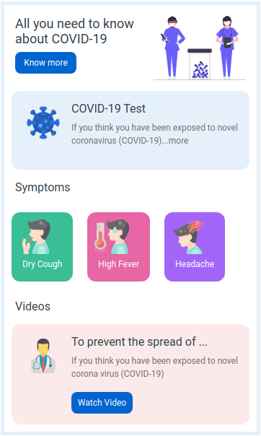

**Note**:

Try to achieve the design as close as possible.

**Resources**

Use the image URLs given below.

URL: <https://d1tgh8fmlzexmh.cloudfront.net/ccbp-static-website/medicalcare-img.png>



URL: <https://d1tgh8fmlzexmh.cloudfront.net/ccbp-static-website/coronavirus-img.png>

background-image-for-corona

URL: <https://d1tgh8fmlzexmh.cloudfront.net/ccbp-static-website/cough-img.png>

background-image-for-corona

URL: <https://d1tgh8fmlzexmh.cloudfront.net/ccbp-static-website/fever-img.png>

background-image-for-corona

URL: <https://d1tgh8fmlzexmh.cloudfront.net/ccbp-static-website/headache-img.png>

background-image-for-corona

URL: <https://d1tgh8fmlzexmh.cloudfront.net/ccbp-static-website/doctor-img.png>

background-image-for-corona

**CSS Colors used:**

Background/ Border color Hex Code values:

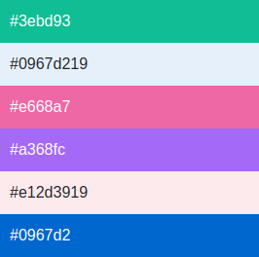

Text color Hex Code values:

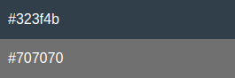

**CSS Font families used:**

* Roboto

8.Goa Page

In this [assignment](http://192.168.253.177/moodle/mod/assign/view.php?id=9464), let's build a Goa Page by applying the concepts we learned till now. You can use the Bootstrap concepts as well.

**Refer to the below image.**

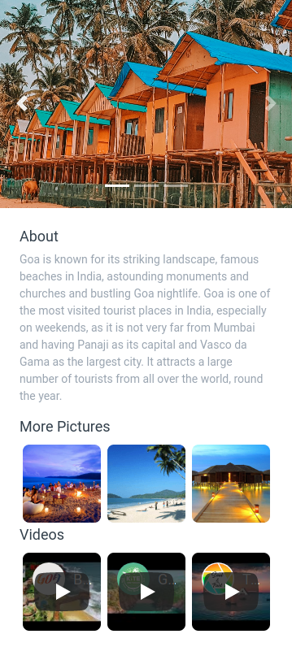

**Note**:

**Resources**

Use the image URLs given below.

Carousel:

* <https://d1tgh8fmlzexmh.cloudfront.net/ccbp-static-website/goa-c1-img.png>
* <https://d1tgh8fmlzexmh.cloudfront.net/ccbp-static-website/goa-c2-img.png>
* <https://d1tgh8fmlzexmh.cloudfront.net/ccbp-static-website/goa-c3-img.png>

More Pictures:

* <https://d1tgh8fmlzexmh.cloudfront.net/ccbp-static-website/goa-more1-img.png>
* <https://d1tgh8fmlzexmh.cloudfront.net/ccbp-static-website/goa-more2-img.png>
* <https://d1tgh8fmlzexmh.cloudfront.net/ccbp-static-website/goa-more3-img.png>

Youtube Video URLs:

* Play Video
* Play Video
* Play Video

**CSS Colors used:**

Text color Hex Code values:

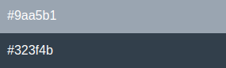

**CSS Font families used:**

* Roboto

Hotel Booking Page

In this [assignment](http://192.168.253.177/moodle/mod/assign/view.php?id=9464), let's build a Hotel Booking Page by applying the concepts we learned till now. You can use the Bootstrap concepts as well.

**Refer to the below image.**

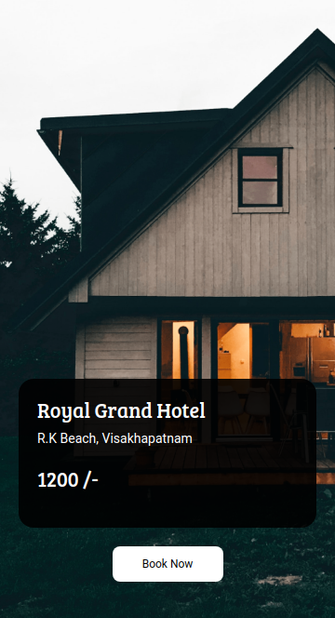

**Note**:

Try to achieve the design as close as possible.

**Resources**

Use this background image,

URL: <https://d1tgh8fmlzexmh.cloudfront.net/ccbp-static-website/hotelbg.png>

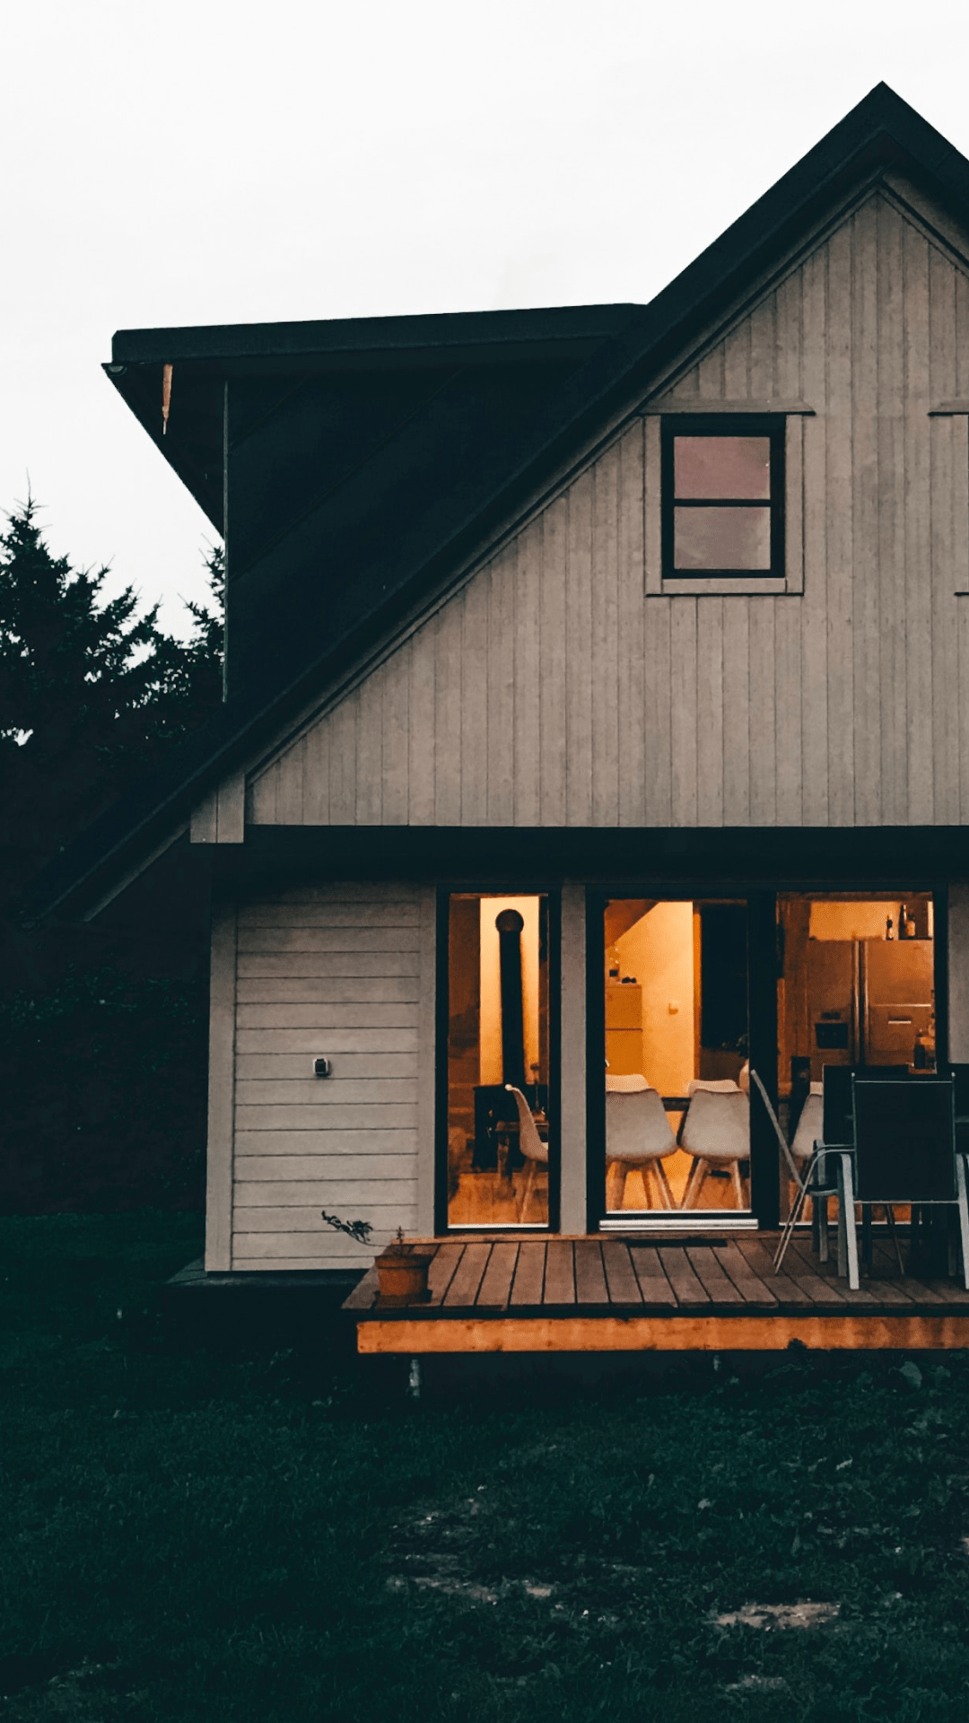

**CSS Colors used:**

Background color Hex Code value for card:

* #000000e6

Background color Hex Code value for button:

* #ffffff

Text color Hex Code value:

* #ffffff

**CSS Font families used:**

* Bree Serif
* Roboto